Public Notice
It is notified for information of General Public and all Concerned that National Savings is going to introduce certain amendments in the rules of National Savings Schemes as mentioned below.
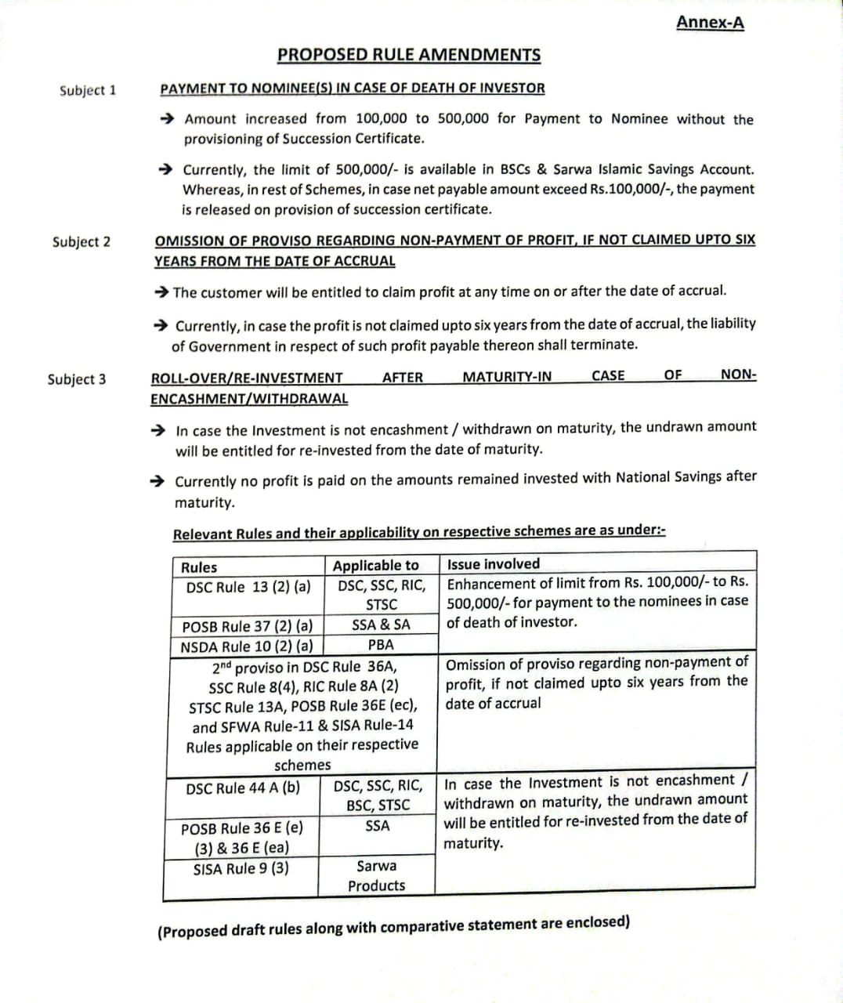

In case of any Objections/Suggestions, the same may be extended to Central Directorate of National Savings for consideration within 15 days that is latest by 30 May, 2025.
The requisite information may be shared at
- pscdns@gmail.com
- Director General, Central Directorate of National Savings, 23/N, Savings House, Civic Centre, G-6 Markaz, Islamabads

